Click here, type the title of your paper, Capitalise first letter only (not all words), Please type: do not copy & paste

First Author[1]*, Second Author2   
(Double Blind Review: Please do not type or edit anything here until final-camera ready submissions)

1First affiliation, City and Country (Please do not type or edit anything here, our editors will do the work for you)

2Second affiliation, City and Country (Please do not type or edit anything here, our editors will do the work for you)

|  |  |  |
| --- | --- | --- |
| ARTICLE INFO |  | ABSTRACT |
| *Article history:*  Received XX Month 2024  Revised XX Month 2024  Accepted XX Month 2024  Online first  Published 1 September 2024 |  | The abstract word count should not be more than **300 words**. Please format your abstract using the ‘Abstract’ style in the styles gallery.  Please **do not edit or remove** any texts or objects highlighted in YELLOW/RED.  Please **read the content of this guideline entirely**. Failure to adhere to this guideline shall lead to manuscript rejection at the desk evaluation stage. |
| *Keywords:*  Keyword1  Keyword2  Keyword3  Keyword4  Keyword5  Keyword6  *DOI:*  10.24191/jcrinn.v9i2 |  |

1. TYPE your heading here (do not copy paste)

The paragraphs continue from here and are only separated by headings, subheadings, images, and formulae. The section headings are arranged by numbers, bold and 10 pt. Here are further instructions for authors.

* 1. Structure of MS word formatting

Files should be in MS Word format only and should be formatted for direct printing. Figures and tables should be embedded and not supplied separately. Please make sure that you use as much as possible normal fonts in your documents. Special fonts, such as fonts used in the Far East (Japanese, Chinese, Korean, etc.) may cause problems during processing. To avoid unnecessary errors, you are strongly advised to use the ‘spellchecker’ function of MS Word. A UK English language is set as default for the  
entire manuscript. Kindly ensure the manuscript is well written with minimum language errors. Any poorly written manuscript will not be accepted at the initial screening stage. Follow this order when typing manuscripts: Title, Authors, Affiliations, Abstract, Keywords, Main text (including figures and tables), Acknowledgements, References, Appendix. Collate acknowledgements in a separate section at the end of the article and do not include them on the title page, as a footnote to the title or otherwise.

Bulleted lists may be included and should look like this:

1. First point
2. Second point
3. And so on

Ensure that you return to the ‘Main Text’ style, the style that you will mainly be using for large blocks of text, when you have completed your bulleted list.

Please do not alter the formatting and style layouts which have been set up in this template document. As indicated in the template, papers should be prepared in single column format. Do not number pages on the front, as page numbers will be added separately for the preprints. Ensure, to leave a line clear between paragraphs by using the right styles (MAINTEXT). All the required style templates are provided in this document with the appropriate name supplied. **Please refer to page 9 for complete guide on styles.**

* 1. Tables

All tables should be numbered with Arabic numerals. Headings should be placed above tables, left justified, and bold. Leave one line space between the heading and the table, by choosing Table Caption in the Styles Gallery. Only horizontal lines should be used within a table, to distinguish the column headings from the body of the table, and immediately above and below the table. Tables must be embedded into the text and not supplied separately. The source of data must be provided i.e., literature (s) or author’s own data. Below is an example which authors may find useful.

Table 1. An example of a table (Font = 8; Click ‘Table Caption’ on the Styles Gallery)

|  |  |  |
| --- | --- | --- |
| **An example of a column heading** | **Column A (*t*)** | **Column B (*T*)** |
| And an entry | 1 | 2 |
| And another entry | 3 | 4 |
| And another entry | 5 | 6 |

Source:

* 1. Construction of references

References should be listed at the end of the paper, should be arranged first alphabetically and then further sorted chronologically if necessary. More than one reference from the same author(s) in the same year must be identified by the letters “a”, “b”, “c”, etc., placed after the year of publication.

Some examples of how your references should be listed are given at the end of this template in the ‘References’ section which will allow you to assemble your reference list according to the correct format and font size. Table 2 shows a guide on construction of different type of reference.



Table 2. Citation style and reference format for different type of references

* 1. Section headings

Section headings (Level A) should be left justified, with all letter capitalised, bold, and numbered consecutively, starting with the INTRODUCTION. Sub-section headings should be in sentence case (Level B), bold, and numbered 1.1, 1.2, etc; and lower-case italic (Level C) letters; and left justified, with second and subsequent lines indented. You may need to insert a page break to keep a heading with its text.

* 1. General guidelines for the preparation of your text

Avoid hyphenation at the end of a line. Symbols denoting vectors and matrices should be indicated in bold type. Scalar variable names should normally be expressed using italics. Dimensions and units of measures should be expressed in SI units. Table 3 shows typical units of measure for this journal. Please title your files in this order firstauthorname.docx.

|  |
| --- |
| Table 3. Typical units of measure |
| |  |  |  |  | | --- | --- | --- | --- | | **Item** | **Dimensions/Parameter** | **Units**  **Do’s and don’t’s** | **Remark** | | Units and symbols | Temperature | 30 °C not 30 oC | Insert symbol degree sign instead of superscript ‘o’ | |  | −30 °C not -30 °C | Insert symbol minus sign instead of *hyphen* | | Absorbance  FTIR length | 1398 cm−1 not 1398 cm-1 | Insert symbol minus sign instead of *hyphen* | | Volume | 15 L not 15 *l* | Use L instead of *l* | | Weight | 150 g not 150g | Always insert space after number for a unit of measure | | Scientific number | 1.3614 × 10−6 not 1.3614 x 10-6 | Insert multiplication symbol instead of using ‘x’ | |

Source: ACS Style Guide (2017)

* 1. Footnotes

Footnotes should be avoided if possible. Necessary footnotes should be denoted in the text by consecutive superscript letters. The footnotes should be typed single spaced, and in smaller type size (8pt), at the foot of the page in which they are mentioned and separated from the main text by a short line extending at the foot of the column. The ‘footnote’ style is available in this template for the text of the footnote.

* 1. Referencing and citation style

The manuscript’s references and citations should be written using the APA 7th edition style. In terms of the in-text citation style, APA uses the author's last name and the year of publication, for example: (Field, 2005); (Field & Thomas; 2014). If there are three or more authors, cite only the surname of the first author followed by “et al.” and the year., for example: (Field et al., 2017). For direct quotations, include the page number as well, for example: (Field, 2005, p. 14). Citing same authors of the same year should be assigned by alphabet following the year of publication (e.g., Field et al., (2014a); Field et al., (2014b)).

Table 2 shows the details of referencing according to the APA 7th edition style. The sample references are available on page 7. Please refer to the following website for further details on APA 7th edition referencing style: <https://libraryguides.vu.edu.au/apa-referencing>

1. Author artwork

All figures should be numbered with Arabic numerals (1,2,...n). All photographs, schemas, graphs and diagrams are to be referred to as figures. Line drawings should be good quality scans or true electronic output. Low-quality scans are not acceptable. Figures must be both embedded into the text and all images should met the minimum requirement of 500 x 500 pixels. Lettering and symbols should be clearly defined either in the caption or in a legend provided as part of the figure. Figures should be placed at the top or bottom of a page wherever possible, as close as possible to the first reference to them in the paper.

* 1. Diagrams

Diagrams can be in the form of framework, process flow, chart, or any visual aids that are meant to support the written text. Any diagrams built using Microsoft Word or Microsoft Power Point’s Smart Art Graphic Tool needs to be embedded as editable or vector-based objects (instead of image objects). Diagrams attached using bitmap-based images (jpeg., png., and other formats) need to be in high resolution (at least 300 pixels per inch).

2.2.1. Texts embedded in diagrams

The font used for labels or indicators inside the diagram needs to be formatted as Times New Roman with font size set at 9. It must not be bold, italicised or underlined.

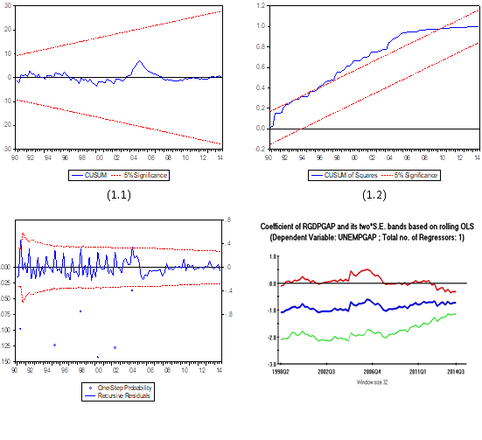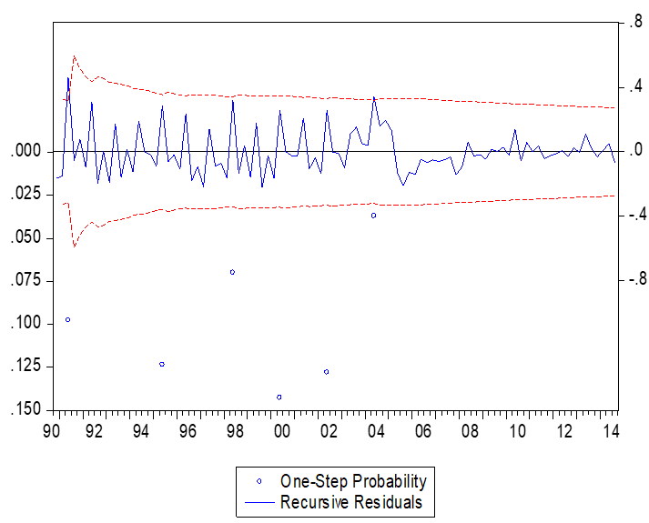

Fig. 1. (left) this figure is blurry, which is unacceptable; (right) this figure has a higher resolution. However, the labels are not formatted using Times New Roman font. (Font = 9; Click ‘Figure Caption’ on the Styles Gallery)

Source:

**Socio-economic factors**

Savings to income ratio

Financial status

Income adequacy

**Financial literacy**

**Financial behaviour**

**Debt burden**

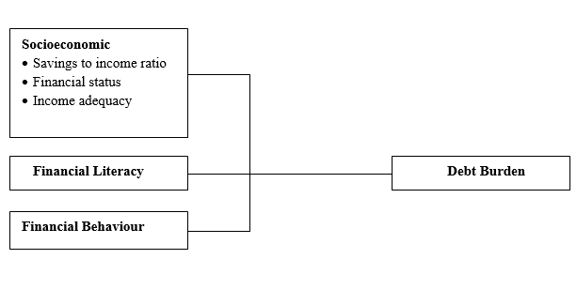

Fig. 2. (left) this framework is a non-editable diagram, appears blurry and hence, is unacceptable;   
(right) this framework is built using MS Word illustration tools, has higher resolution and is acceptable.   
(Font = 9; Click ‘Figure Caption’ on the Styles Gallery)

Source:

Please use the ‘drawing canvas tool’ in MS Word before inserting any images or diagrams into the document. When constructing a conceptual/theoretical framework, please use editable or vector-based diagrams. Draw diagrams using MS Word’s Smart Art Graphic Tool (textboxes, labels, arrows, legends, etc.) rather than embedding non-editable image objects. Ensure that all the figures have a good resolution (minimum 300dpi) and are not fuzzy or blurry.

* 1. Captions

The figure number and caption should be typed below the illustration in 9pt and left justified. Artwork has no text along the side of it in the main body of the text. However, if two images fit next to each other, these may be placed next to each other to save space, see Fig. 1. They must be numbered consecutively, all figures, and all tables respectively.

1. Equations and formulas

Equations and formulae should be typed and numbered consecutively with Arabic numerals in parentheses on the right-hand side of the page (if referred to explicitly in the text). They should also be separated from the surrounding text by one space. Eq. (1) shows the sample of equation position in a manuscript. If you chose to use the Equation Editor, please ensure that the manuscript is saved using .docx format   
(rather than .doc), and Compatibility Mode is turned off.

|  |  |  |
| --- | --- | --- |
|  | Rt = K EP = 93.02 (± 9.62) – 13.45 | (1) |

1. Acknowledgements/Funding

(DOUBLE-BLIND reviewing. Leave the section as is. Only include Acknowledgements text in the final submission paper)

This section is compulsory. The following is an example of an acknowledgement statement:

The authors would like to acknowledge the support of Universiti Teknologi Mara (UiTM), Cawangan Negeri Sembilan, Kampus Kuala Pilah and Faculty of Applied Sciences, Universiti Teknologi MARA, Shah Alam, Selangor, Malaysia for providing the facilities and financial support on this research.

1. Conflict of interest statement

(DOUBLE-BLIND reviewing. Leave the section as is. Only include CONFLICT OF INTERESTS text in the final submission paper)

This section is compulsory. The following is an example of a conflict-of-interest statement:

The authors agree that this research was conducted in the absence of any self-benefits, commercial or financial conflicts and declare the absence of conflicting interests with the funders.

1. Authors’ contributions

Each author contribution must be stated clearly reflecting each contribution to the body of the work and manuscript. Authors can refer to [CRediT](http://credit.niso.org/) (Contribution Roles Taxonomy) for the detailed information about individual contributions to the work. For example ***(Double Blind Review: Leave this section blank until final camera-ready submission)*:**

**Anis Muneerah Shaiful Bahari**: Conceptualisation, methodology, formal analysis, investigation and writing-original draft; **Nurhaswani Alias**: Conceptualisation, methodology, and formal analysis; **Zainovia Lockman**: Conceptualisation, formal analysis, and validation; **Haslina Misran**: Conceptualisation, supervision, writing- review and editing, and validation.

1. References

Vuthaluru, H. B. (2004). Thermal behaviour of coal/biomass blends during co-pyrolysis. *Fuel Processing Technology, 85*(2–3), 141–155. <https://doi.org/10.1016/S0378-3820(03)00112-7>

Ahmed, I. I., & Gupta, A. K. (2010). Pyrolysis and gasification of food waste: Syngas characteristics and char gasification kinetics. *Applied Energy, 87*(1), 101–108. <https://doi.org/10.1016/j.apenergy.2009.08.032>

Yang, Y., Wang, G., Peng, C., Deng, Q., Yu, Y., He, X., Hu, T., Jiang, L., Shan, S., Zheng, Y., Zhi, Y., & Su, H. (2023). Microwave-assisted synthesis of l-aspartic acid-based metal organic aerogel (MOA) for efficient removal of oxytetracycline from aqueous solution. *Applied Surface Science, 610*, Article 155608. <https://doi.org/10.1016/j.apsusc.2022.155608>

Yang, H., Li, J., Jiang, H., Hu, J., Zeng, J., & Nie, C. (2018, March 26–28). *Alkaline-surfactant-polymer flooding: Where is the enhanced oil exactly?* [Paper presentation]. Society of Petroleum Engineers (SPE) 2018 EOR Conference at Oil and Gas West Asia, Muscat, Oman. <https://doi.org/10.2118/190340-MS>

Energy Commission. (2019). *Malaysia Energy Statistics Handbook 2019*. https://meih.st.gov.my/documents/10620/bcce78a2-5d54-49ae-b0dc-549dcacf93ae

American Society for Testing and Materials (2015) *standard test methods for proximate analysis of coal and coke by macro thermogravimetric analysis* (ASTM D7582-15) West Conshohocken, PA. https://www.astm.org

Matali, S. (2019). *Production and kinetic study of torrefied oil palm frond and leucaena leucocephala pellets for co-combustion with silantek coal* (Issue 28308) [Doctoral Thesis, Universiti Teknologi MARA]. UiTM Institutional Repisotory. <https://ir.uitm.edu.my/id/eprint/28308>

Ian C. Kemp. (2007). *Pinch analysis and process integration a user guide on process integration for the efficient use of energy* (Second Edition). Butterworth-Heinemann, Elsevier.

Thompson, C. (2012). How can we develop an evidence-based culture? In J. V. Craig & R. L. Smith (Eds.). *The evidence-based practice manual for nurses* (3rd ed., pp. 323–357). Churchill Livingstone Elsevier. <https://www.elsevier.com/books/the-evidence-based-practice-manual-for-nurses/craig/978-0-7020-4193-8>

Bavani, M. (2021, April 15). Putting an end to food waste. *The Star.* [*https://www.thestar.com.my/metro/metro-news/2021/04/15/putting-an-end-to-food-waste*](https://www.thestar.com.my/metro/metro-news/2021/04/15/putting-an-end-to-food-waste)

|  |  |
| --- | --- |
|  | © 2024 by the authors. Submitted for possible open access publication under the terms and conditions of the Creative Commons Attribution (CC BY) license (http://creativecommons.org/licenses/by/4.0/). |

An example appendix

Authors including an appendix section should do so after References section. Multiple appendices should all have headings in the style used above. They will automatically be ordered A, B, C etc.

1. *Example of a heading within an appendix*
   1. *Example of a sub-heading within an appendix*

There is also the option to include a subheading within the Appendix if you wish.

**About the Authors**

Please submit another separate file by naming it as “Author Information”. Avoid revealing the identity and information of the authors in the manuscript (that should be anonymous). Provide the following information in the separated file.

*Author 1 (Full Name, without Titles/Designation)*, Please summarise the academic background and details of the author, and contact information (an e-mail address is compulsory). The authors’ biographical information will be displayed after the Reference List. Maximum number of words is 100.

*Author Full Name 2 (Full Name, without Titles/Designation)*, Please summarise the academic background and details of the author, and contact information (an e-mail address is compulsory). The authors’ biographical information will be displayed after the Reference List. Maximum number of words is 100.

*EXAMPLE:   
Danial Rashid, PhD* is Associate Professor in the Department of Management and Finance at the University of Nusantara. His main research activity is in the area of organizational innovation and organizational learning. He has published widely on these subjects in publications such as the *International Journal of HRM, Industrial Marketing Management,* *Journal of Business Research*, *International Journal of Information Management and Management Decision*. His can be reached through his email at [danialrashid@nusantarauni.edu.my](mailto:danialrashid@nusantarauni.edu.my)

**Style Formatting: Special Instruction to Authors (Please read this)**

* Authors are required to edit the template using Microsoft Word 2010 onwards.
* Authors must use the ‘Styles Gallery’ to format the written contents of the article.
* The Styles Gallery is located within the Home Ribbon, in the Styles Pane.

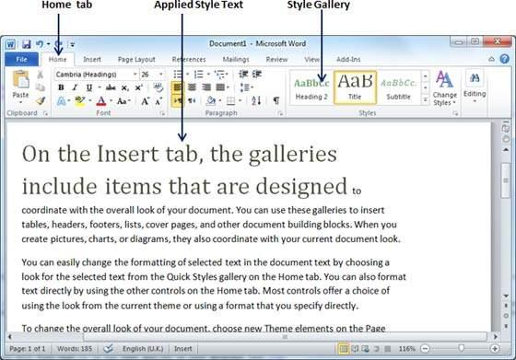

* The ‘Styles Gallery’ appears as follows:
* Please utilise the Styles Gallery when formatting your article.
* Please avoid doing the following:
  + adjust the paragraph parameters
  + increase or decrease indentation
  + create new headings
* If the formatting appears to stray away from the requirements, select the affected paragraphs/headings, and click the “Clear Formatting” icon at the ‘Font’ section of the ‘Home’

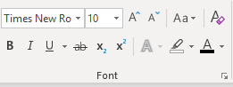

The formatting will be reset. Again, apply the intended formatting by clicking the specific style using the Styles Gallery.

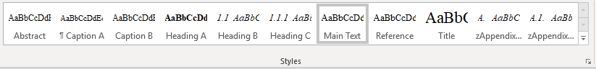

Please refer to the table below to understand the target use of each of the specific style.

|  |  |
| --- | --- |
| **Style Name** | **Targeted Use** |
| Title | Main title |
| Author | Authors’ names *\*corresponding author’s details are located at the footnote section of the first page* |
| Affiliation | Author’s institutional affiliation |
| Footnote | Corresponding author’s e-mail address (use institutional e-mail address instead of free e-mail such as Gmail, Yahoo etc.) |
| Heading A | Main header with numbering (1,2,3…) |
| Heading B | Second level header (e.g. 1.1, 1.2, …) |
| Heading C | Third level header (e.g. 2.2.1, 2.2.2, …) |
| Main Text | The write-up of the article |
| * Main Text Heading A | The write-up right after Heading A |
| * Main Text Heading B | The write-up right after Heading B |
| * Main Text Heading C | The write-up right after Heading C |
| Equation | For equation |
| Table Caption | Caption for Table |
| Figure Caption | Caption for Figure |
| Reference | Bibliographic reference with indentation |
| Appendix Heading 1 | Appendix header with lettering (A. B, C …) |
| Appendix Heading 2 | Appendix second-level header with alphanumeric coding (e.g. B1. B2, B3 …) |

1. * Corresponding author. *E-mail address*: [donottypehere@email.com](mailto:donottypehere@email.com) (Add the e-mail in the final camera-ready submission)